**DAILY ONLINE ACTIVITIES SUMMARY**

|  |  |  |  |  |  |  |  |  |
| --- | --- | --- | --- | --- | --- | --- | --- | --- |
| **Date:** | **06/06/2020** | | | | | **Name:** | **PONICA.J** | |
| **Sem & Sec** | **4TH & B** | | | | | **USN:** | **4AL18CS055** | |
| **Online Test Summary** | | | | | | | | |
|  | | **DATA COMMUNICATION** | | | | | | |
| **Max. Marks** | | **30** | | **Score** | | | **27** | |
| **Certification Course Summary** | | | | | | | | |
| **Course** | **FIREBASE ML** | | | | | | | |
| **Certificate Provider** | | | **UDEMY** | | **Duration** | | | **3 HOURS** |
| **Coding Challenges** | | | | | | | | |
| **Problem Statement:** Given an array A of size N containing 0s, 1s, and 2s; you need to sort the array in ascending order. | | | | | | | | |
| **Status:EXECUTED** | | | | | | | | |
| **Uploaded the report in Github** | | | | | **YES** | | | |
| **If yes Repository name** | | | | | **https://github.com/ponica-jaya/LOCKDOWN-CODING.git** | | | |
| **Uploaded the report in slack** | | | | | **YES** | | | |

Online Test Details: (Attach the snapshot and briefly write the report for the same)

Today I had test for 45 mins subject data communication from 9.30 am to 10.10am which had 30 mcq questions and I have attached my test snapshot which results.

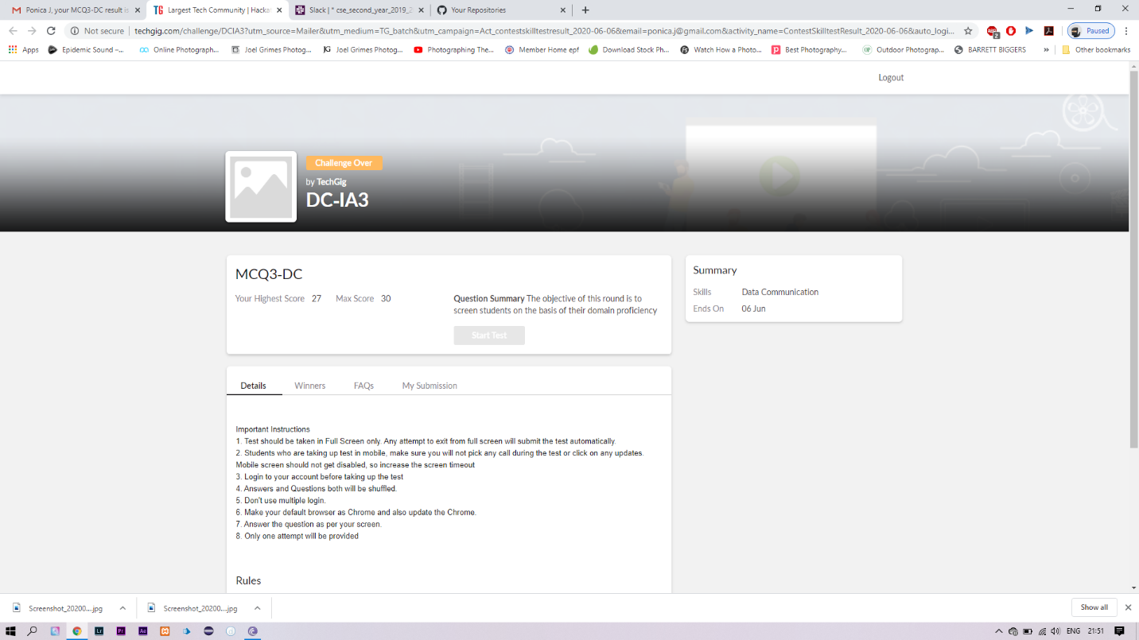

Certification Course Details: (Attach the snapshot and briefly write the report for the same)

I have attached my course snapshot and I have got my certificate too.



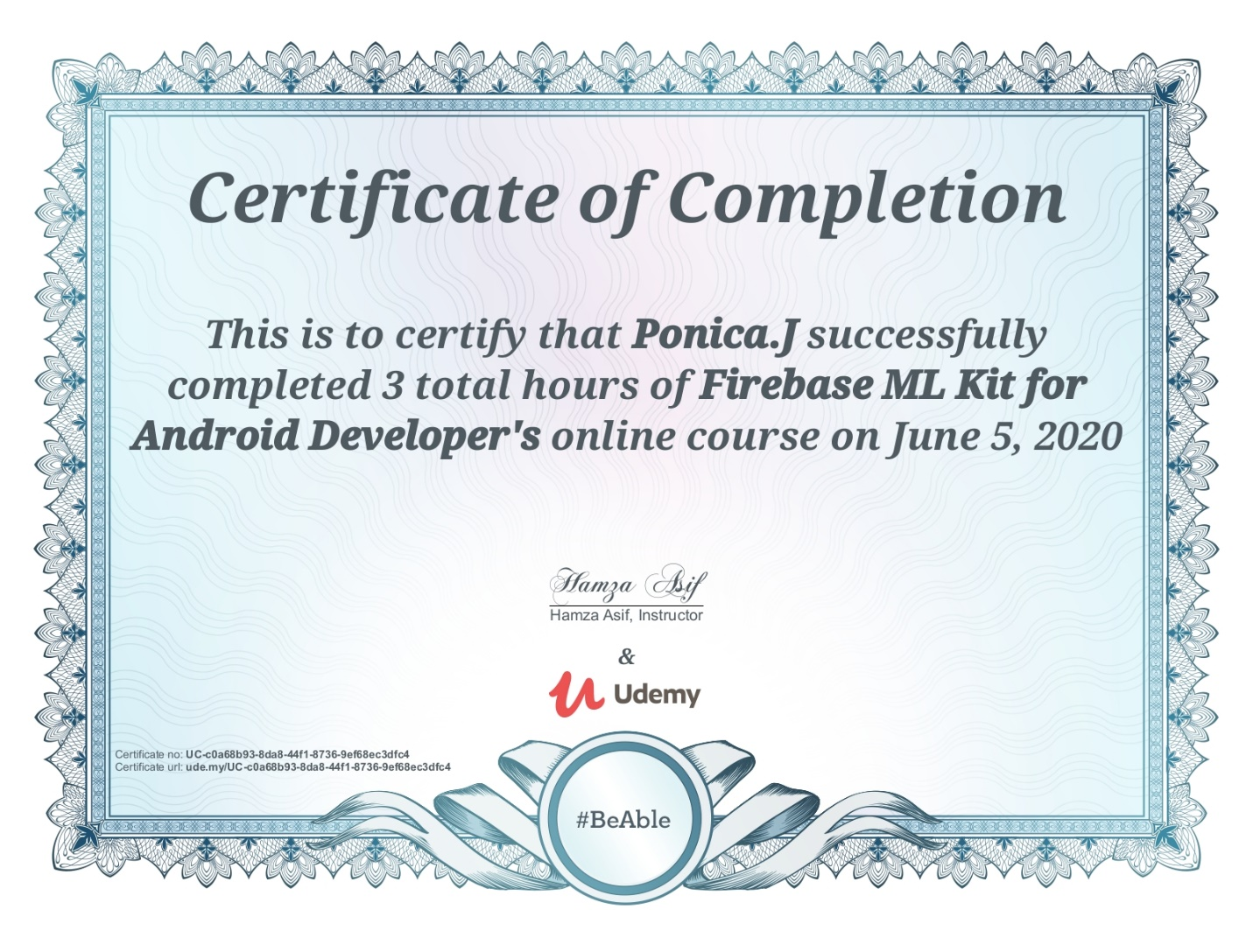Coding Challenges Details: (Attach the snapshot and briefly write the report for the same)

Given an array A of size N containing 0s, 1s, and 2s; you need to sort the array in ascending order.  
Input:  
The first line contains an integer 'T' denoting the total number of test cases. Then T testcases follow. Each testcases contains two lines of input. The first line denotes the size of the array N. The second lines contains the elements of the array A separated by spaces.

Output:  
For each testcase, print the sorted array.

Constraints:  
1 <= T <= 500  
1 <= N <= 106  
0 <= Ai <= 2

Example:  
Input :  
2  
5  
0 2 1 2 0  
3  
0 1 0

Output:  
0 0 1 2 2  
0 0 1

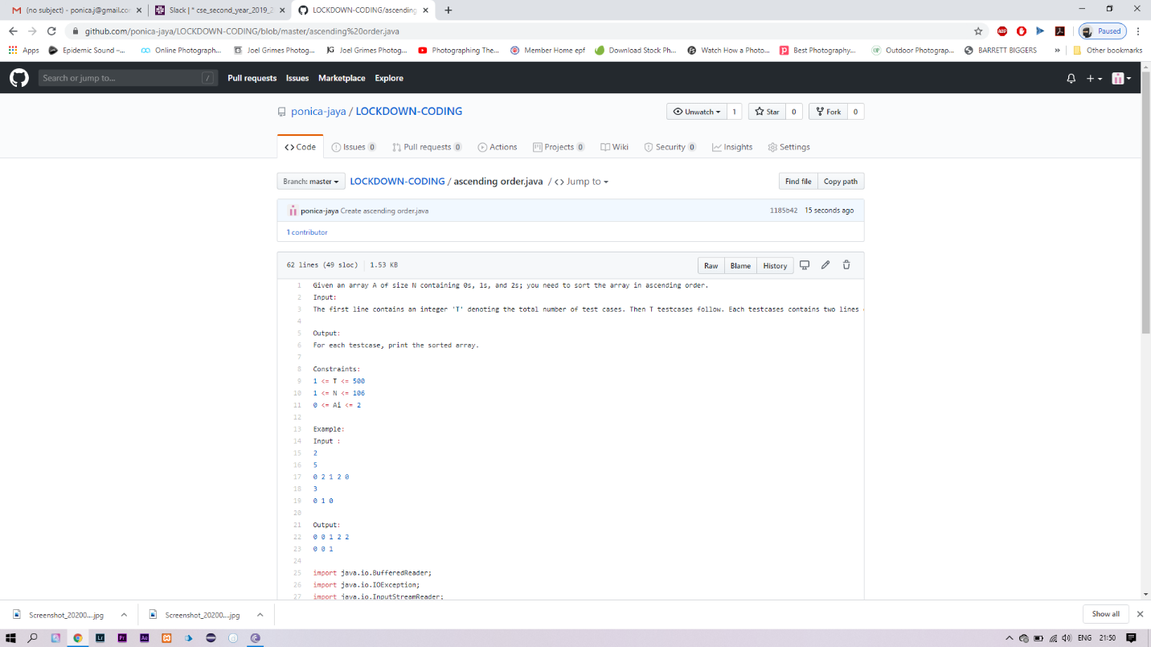.

SOLUTION I HAVE SOLVED AND THEN UPLOADED IN GITHUB ACCOUNT AND EVEN I HAVE ATTACHED THR SNAPSHOT OF IT